**4. Evaluation**

This section demonstrates the test and evaluation of each subsystem of Intellitune against the stated technical design constraints. Each of these individual subsystems ensure that the constraints described in Table 4.1 are met and verify that they are ready to be integrated into the final product. The subsystem tests are followed by a system test at the end that demonstrates the subsystems can function successful as one entire product.

**Table 4 - Technical Design Constraints**

|  |  |
| --- | --- |
| **Name** | **Description** |
| Power Rating | The Intellitune must be capable of handling 1.5 kW of transmitting power. |
| Bandwidth | Tuning circuitry must pass through frequencies in the 1.5 MHz to 30 MHz band. |
| VSWR Sensing | The Intellitune must measure the forward and reflected power to determine the voltage standing wave ratio (VSWR) for up to a 32:1 mismatch. |
| Frequency Sampling | The microcontroller must sample the transmitting signal and determine the frequency up to the maximum 30 MHz limit. |
| Impedance Matching | The Intellitune must provide a tuning network that is capable of matching antenna impedances from 12-1600 ohms. |

**4.1 Test Certification - User Interface**

The user interface of Intellitune is located on the front panel and comprised of the LCD display and push buttons. The LCD display will show the user the VSWR reading, forward and reflected power, and the frequency. The user can send a command to the microcontroller by pressing its respective button. Additionally, if the mode button is held down for more than two seconds, a settings menu appears. The available buttons are Tune, Inductance-Up, Inductance-Down, Capacitance-Up, Capacitance-Down, Antenna, and Mode. For the evaluation of this subsystem, a test was conducted where each button was pressed individually, and it was verified that the appropriate action was triggered. The table below summarizes these tests.

**Table 4.1 Push Button Checklist**

|  |  |  |
| --- | --- | --- |
| **Button** | **Expected function** | **Status** |
| Tune | Initiate tuning process | Functional |
| Inductance-Up | Turn variable inductor to add additional inductance | Functional |
| Inductance-Down | Turn variable inductor to decrease additional inductance | Functional |
| Capacitance-Up | Turn variable inductor to add additional capacitance | Functional |
| Capacitance-Down | Turn variable inductor to decrease additional capacitance | Functional |
| Antenna | (Currently un-utilized) | N/A |
| Mode | Cycles through the different displays | Functional |
| Settings Menu (triggered by mode button) | Pulls up the available settings for the tuner | Functional |

**4.2 Test Certification - Wideband Current Transformer**

The wideband current transformer is an essential design constraint for sensing the VSWR. This subsystem satisfies the technical constraint of measuring the forward and reflected power to determine the VSWR for up to a 32:1 mismatch. The procedure for this test began with connecting a 50-ohm load to Intellitune’s antenna output to calibrate for a 1.0 VSWR reading. Next, different known loads were connected to verify that the experimental reflection coefficient was close to the theoretical value. In addition to this, there was an external VSWR meter attached in series to confirm that the readings from Intellitune’s wideband current transformer were in fact close to the actual value.

In Figure 4.2a below, the oscilloscope display shows the forward and reflected voltages measured during the test. Channel one is measured at 1.44 Volts and channel two shows 112 mV. Using the formula for calculating VSWR shown in Figure 4.2b, the reflection coefficient is found, and then using 4.2c, the Intellitune found the VSWR to be 1.168.

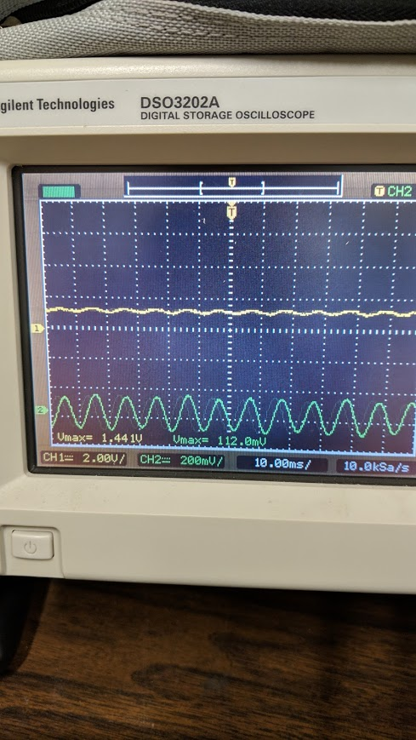

**Figure 4.2a Oscilloscope reading of forward and reflected voltages**

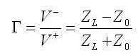

**Figure 4.2b Formula used to calculate reflection coefficient (gamma) where V- is the reflected wave and V+ is he incident wave**

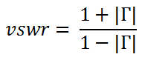

**Figure 4.2c Formula used to calculate VSWR using gamma**

In Table 4.2 below, the value of the load is varied for each test. The expected VSWR was derived using the reflection coefficient calculated from the impedance of the load. An external VSWR meter was attached in series to confirm that the values matched Intellitune’s, and the percent error the two were recorded in the table.

**Table 4.2 VSWR Sensor Test Data**

|  |  |  |  |  |
| --- | --- | --- | --- | --- |
| **Resistance** | **Expected SWR** | **External VSWR Reading** | **Intellitune VSWR Reading** | **% Error** |
| 50 Ohm | 1.0 | 1.1 | 1.168 | 6.2% |
| 100 Ohm | 1.71 | TBD | TBD | TBD |
| 25 Ohm | 1.71 | TBD | TBD | TBD |

**4.3 Frequency Counter Testing**

The frequency counter subsystem utilizes the frequency counter circuit and the microcontroller to satisfy the technical constraint of sampling the transmitted signal and determining the frequency up to 30 MHz. For testing, the waveform generator in Figure 4.2 was used to send a square wave signal to the microcontroller at various frequencies. The calculated frequency was then displayed on the LCD. After the first successful test, additional tests were performed where the frequency, waveform type, and voltage were varied across each test to ensure complete functionality. Test results of the frequency counter are shown in Table 4.2, and the frequency counter was found to be accurate up to 3 decimal places as shown in Figure 4.3.

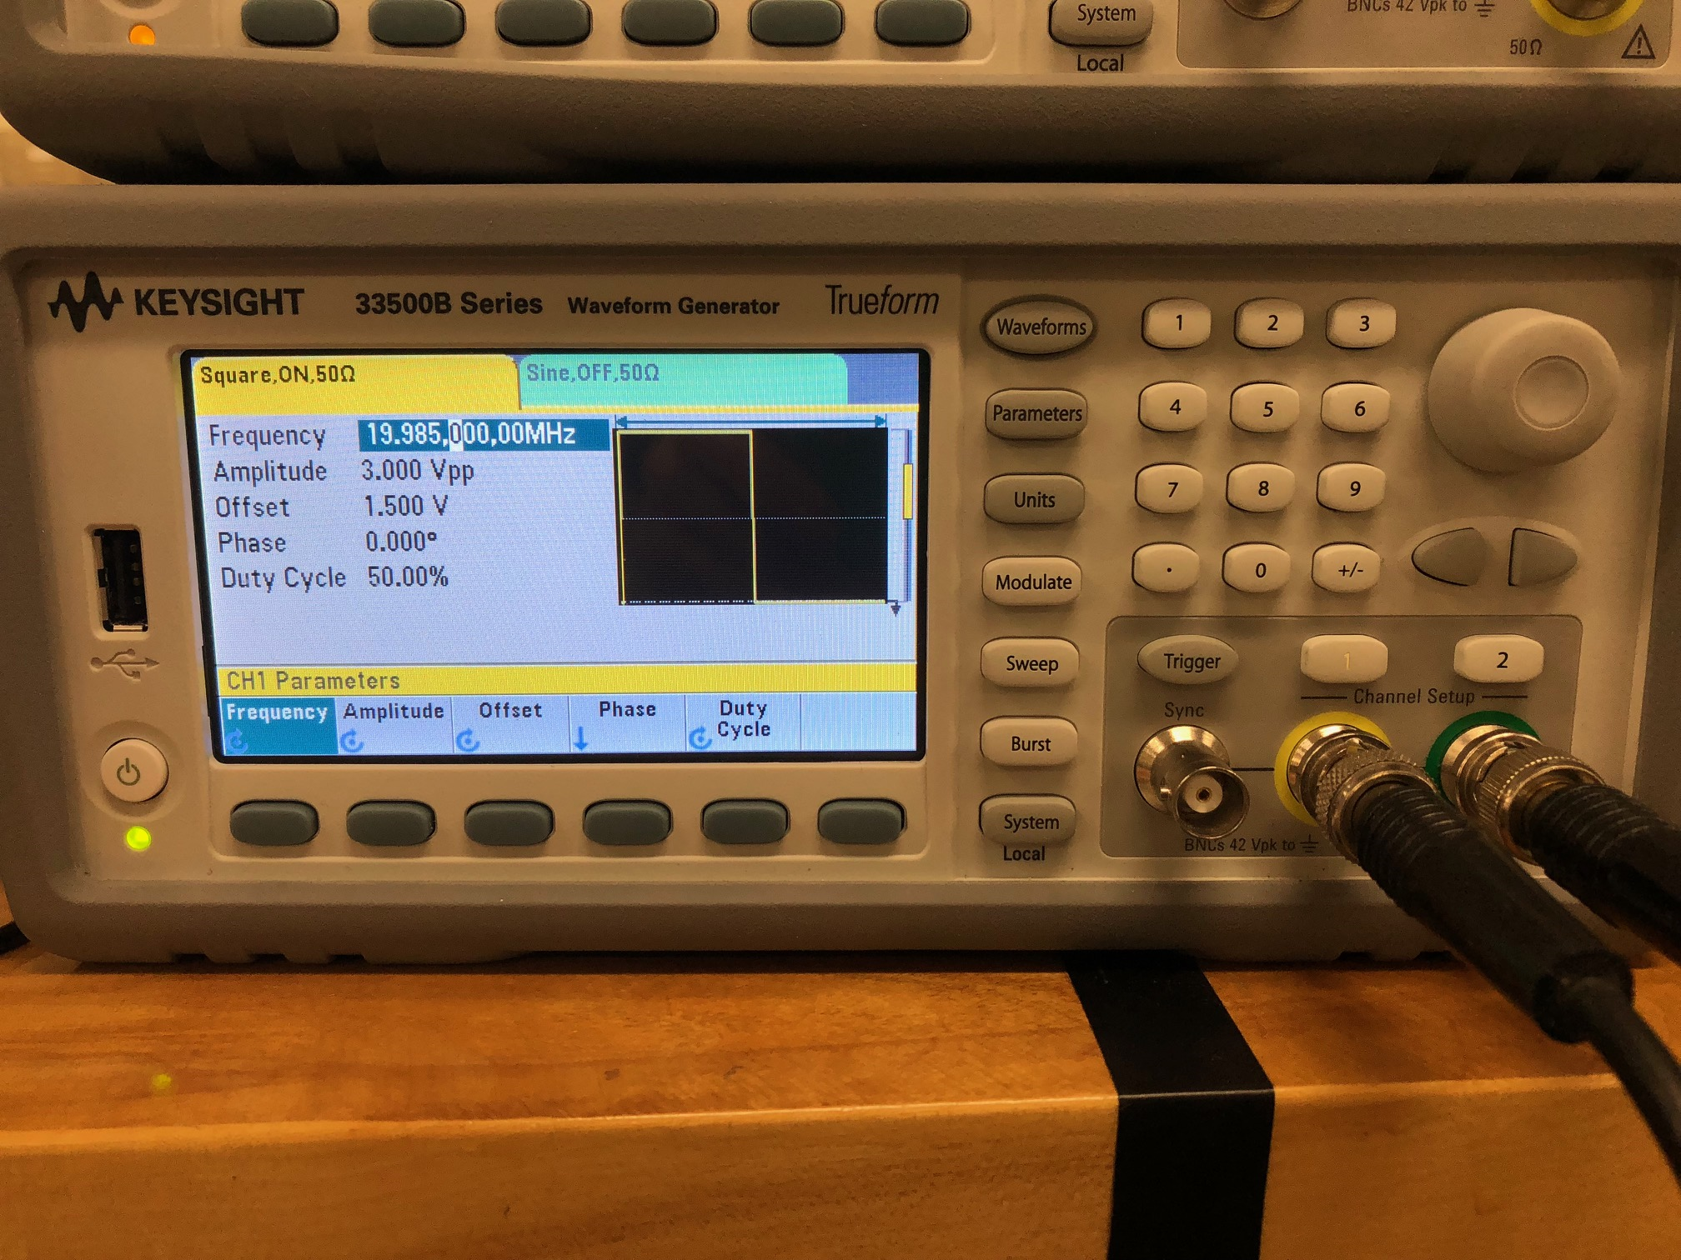

**Figure 4.3a - Waveform Generator Test Setup**

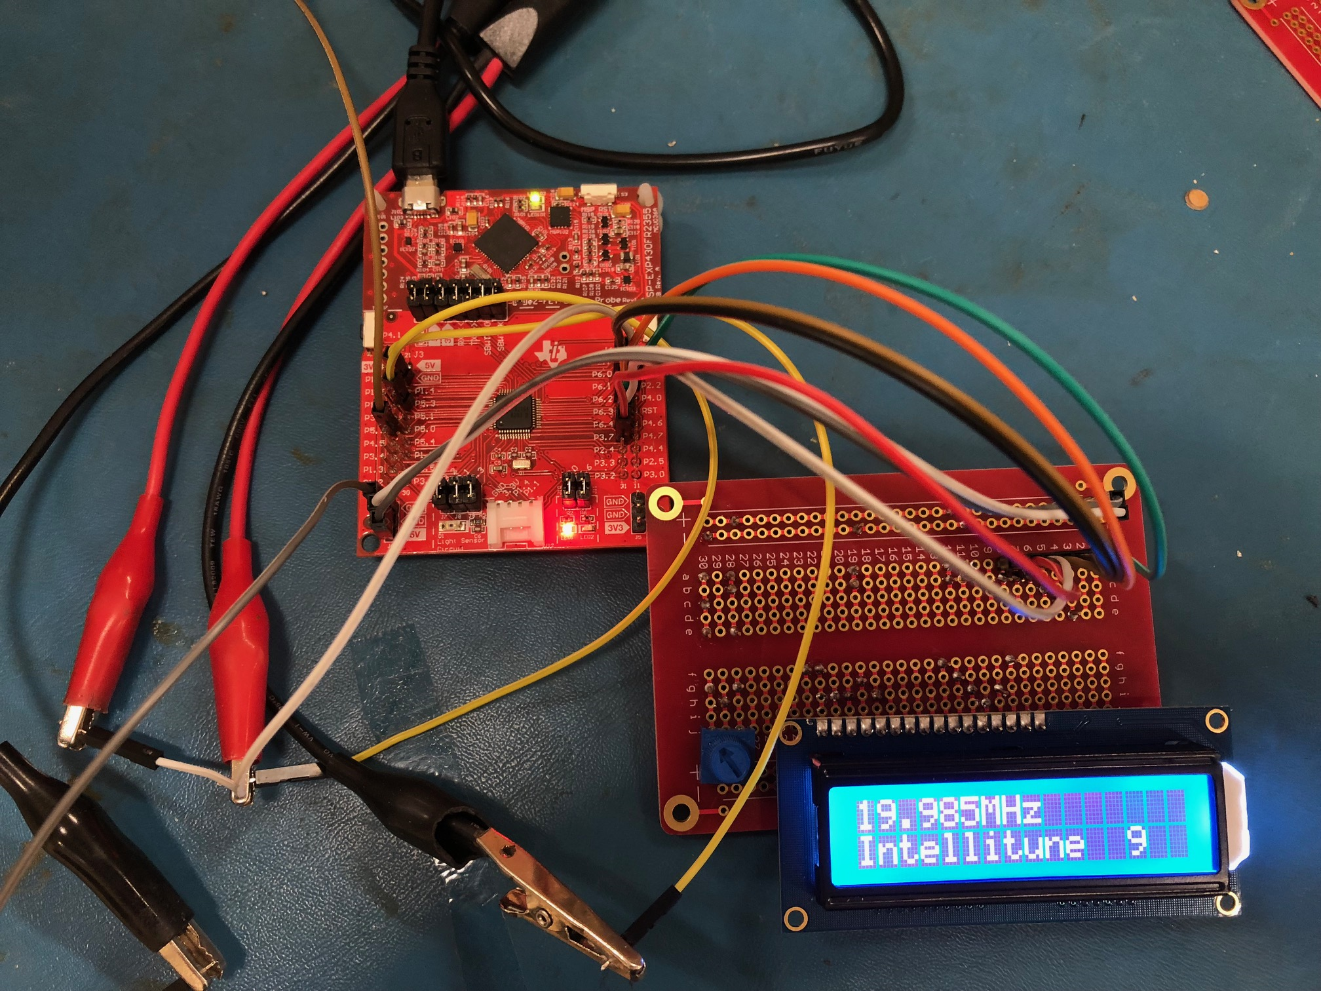

**Figure 4.3b - Test Results of 19.985 MHz Sampled Frequency**

|  |  |  |  |
| --- | --- | --- | --- |
| **Frequency Generated** | **Waveform Type** | **Voltage (Vpp)** | **Frequency Sampled** |
| 3.622 MHz | sine | 3.0 | 3.622 MHz |
| 3.622 MHz | square | 3.0 | 3.622 MHz |
| 19.15 MHz | sine | 4.0 | 19.15 MHz |
| 19.15 MHz | square | 4.0 | 19.15 MHz |

**Table 4.3 Frequency sampling test cases**

**4.4 Test Certification - Stepper Motor Subsystem**

The stepper motor subsystem consists of the driver code on the microcontroller, two stepper motors, and two stepper motor drivers. Together, these components adjust the variable inductor and the variable capacitor to achieve the needed impedance. The first step of evaluating this subsystem was to use the microcontroller to command the motors to rotate without connection to the variable components. Once it was confirmed that the motors were rotated successfully, the motors were then attached to the variable components. Once again, the microcontroller was used to turn the stepper motors. Afterwards, the shafts were checked for slippage or dislocation so that it could be confirmed that the parts were connected firmly.

When integrated with the system, it was possible to check to ensure that the proper amount of inductance or capacitance was being added. When the tuning algorithm begins, the LCD display shows an estimated impedance, which is the impedance that the microcontroller believes that Intellitune needs to add. The stepper motors will then rotate the variable components to this estimated impedance, and then begin a fine tuning process to get the precise value. This information is further outlined in the system test section.

**4.5 Relay Circuit Subsystem**

The relay circuit subsystem is responsible for switching in certain capacitors during the tuning algorithm. Due to the complexity of the circuit, it is crucial to test this subsystem to ensure that everything is assembled correctly before proceeding. To perform this test, the microcontroller was programmed to call out commands that would execute the switching of the relays. The switch of each relay is audible so hearing that sound is the first signal that the relay is functioning. After the switching noise was heard, a multimeter was used to ensure that the internal configuration of the relay routed the wiring properly. Table 4.5 describes the test process in full.

**Table 4.5 Relay Circuit Test Summary**

|  |  |  |  |
| --- | --- | --- | --- |
| **Relay Number** | **Description** | **Audible Noise** | **DMM Check** |
| 1 | variable inductor relay | heard | Connectivity present |
| 2 | 470 pF cap relay | heard | Connectivity present |
| 3 | 940 pF relay | heard | Connectivity present |
| 4 | 1,410 pF relay | heard | Connectivity present |
| 5 | 25 Ohm relay | heard | Connectivity present |

**4.6 Test Certification - Impedance Matching Code**

The microcontroller executes the impedance matching code in order to satisfy the design constraint of providing a tuning network that is capable of matching antenna impedances from 12 to 1600 ohms. The first step of the test was to input the dummy reflection coefficient to verify the algorithm calculations. Next, known dummy loads were connected, and then it was verified that the correct load and VSWR were calculated. After that, the motors were inspected to ensure that they adjusted to the calculated tuning values.

**4.7 Test Certification- Power Handling Capability**

The final Intellitune must be capable of handling 1.5 kW. For the prototype this semester, the aim is to operate at 50 W. Further testing for the power handling capability will be executed next year as part as the system test.

**4.8 System Test**

After all of the subsystems proved to be function, various system tests were executed in order to verify functionality of Intellitune. In each test, the dummy load is varied, as well as the power level and the frequency. The first step was to place Intellitune between the transceiver and the dummy load. Next, FM signals were transmitted at different frequencies and powers described in Table 4.8. In each case, the initial VSWR reading was noted for later comparison. After setup is complete, the tuning process was initiated using the push button on the user interface. When the tuning algorithm completed its cycle, the resulting VSWR data was compared to the expected.

For this semester, the frequencies will be kept relatively low to avoid stray capacitance, however this should not remain an issue next semester after the printed circuit board (PCB) is manufactured, and there are less wires. Additionally, the power will be kept under 50 watt until Intellitune can be reinforced and made more robust next semester. Before the system test begins, it is expected that there will be an VSWR greater than two, so the goal is to lower that measurement to somewhere below two. A summary of this test is described in the table below.

**Table 4.8 System Test Cases**

|  |  |  |  |  |  |
| --- | --- | --- | --- | --- | --- |
| **Frequency** | **Transmitted Power** | **Load** | **Initial SWR reading** | **Initial Calculated SWR** | **Final Measured SWR** |
| 18.07 MHz | 20 W | 100 Ohms  1.36 uH  54.48 nF | 3.3 | 3.3 | 1.3 |
| 7.04 MHz | 15 W | 100 Ohms  2.6 uH  136.8 nF | 2.5 | 2.0 | 1.4 |
| 7.02 MHz | 15 W | 100 Ohms  1.3 uH  51.36 nF | 1.7 | 1.5 | 1.3 |